Dr J Lenten
The Queens Road Medical Centre,
220 Queens Road, Leicester, LE2 3FT
0116 2702233
January 2016
A LETTER TO ALL MY PATIENTS
It is with an extremely heavy heart that I find myself having to write this letter to you. It was always my intention to continue the practice for at least the next ten years, and to have been put in this position is heart breaking. Unfortunately, in the current healthcare environment, small practices are becoming unviable, as the workload has reached an unsustainable level and access to funding is becoming more and more difficult for practices which are set up like ours in the traditional way.
This decision is in no way a reflection on how hard everyone within the practice has been working; I have the utmost praise and admiration for all the staff who have worked tirelessly, often under extreme pressure, to offer you all the best possible care and attention possible.
Please be assured that Sam and I have not taken this decision lightly – the practice is far more than a job to us – it is our life and I have seen the wonderful relationships that I have built up with many of you to be my life’s work.
You will also receive a letter from the CCG which explains the process which it will follow and what action you will need to take.
Please note that we will continue to offer the full range of services to our patients until 31st March. If you are contacted about coming in to see us, it would be very helpful if you could make all attempts to do so – we would like to transfer your care having undertaken all the checks etc that we are required to do before you change GPs.
With my very best wishes
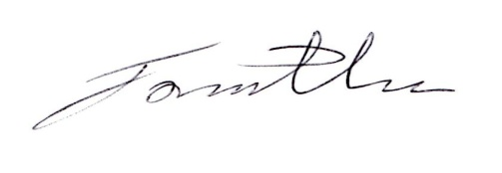
Dr Jonathan Lenten

