

**Evening and weekend GP appointments now available for Leicester City patients**

**Opening times:**

Weekdays: 18:30 to 22:00

Weekends and bank holidays: 09:00 to 22:00

Call **0116 366 0560** during our opening hours for a same day appointment

**Brandon Street Surgery**

Belgrave Health Centre

52 Brandon Street, Leicester, LE4 6AW

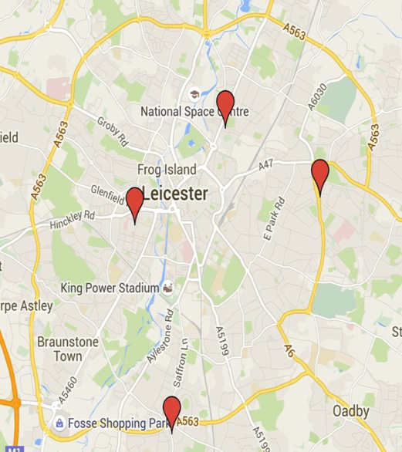

**The Willows Medical Centre**

184 Coleman Road, Leicester, LE5 4LJ



**Westcotes Medical Practice**

Westcotes Health Centre,

Fosse Road South, Leicester, LE3 0LP

**Saffron Surgery**

612 Saffron Lane, Leicester, LE2 6TD

If you are registered with a Leicester City GP practice, you can now get an appointment on the day with a GP or nurse in the evenings and weekends at one of four healthcare hubs (centres), just as you would with your own GP practice. You will be seen by experienced general practitioners and nurses at our centre as part of your NHS Service and will remain registered with your own GP.

This will not affect the service you receive from your usual GP practice.

Patients can book themselves an on-the-day appointment using the patient number above or can walk in to any of the four hubs during opening hours. You may also be referred by your own GP.