*Name*

*Address1*

*Address2*

*Address3*

*Postcode*

28th January 2016

Dear [*All patients registered at Queens Road Medical Centre,**220A Queens Rd, Leicester, LE2 3FT ]*

**Re: Important changes at Queens Road Medical Centre**

We are writing to you with some important information about the services provided by your current GP Practice at Queens Road Medical Centre.

We have been informed by Dr Lenten, the GP at the practice, that he wishes to terminate his contract to provide medical services on 31st March 2016. Unfortunately this means that the practice will be closing on this date.

Since we received Dr Lenten’s resignation, we have been looking at alternative options for your care but, after careful consideration, we have concluded that all of Dr Lenten’s patients will need to register with another GP practice. One of the main reasons for this is the number of other GP practices that are already in the area. Furthermore, many of Dr Lenten’s patients are spread far and wide across the city, and so may wish to use this as an opportunity to register with a practice closer to where they live.

We understand that this may be very disappointing news for you, especially if you have been a patient of Dr Lenten for some time. However, please be assured that we are committed to making sure that you receive the best possible care and want to make sure you continue to have access to a local GP and the full range of services they provide.

What you need to do next

You will now need to register with a new GP practice. We strongly advise you to do this before 31st March 2016, so that you can continue to have access to a GP. There is a wide choice of practices available to you.

Enclosed is a list of GP practices within 1.5 miles of Queens Road Medical Centre that you can register with. If you live further away, you may prefer to register with a practice that is closer to home. You can find out more about all of these practices on the NHS Choices website: [www.nhs.uk](http://www.nhs.uk) or you can contact Patient Registration on 0116 295 7880. We have also enclosed a Frequently Asked Questions list, which you may find helpful.

Once you register with a new practice your patient records will be automatically transferred so that your new doctor and clinical staff can understand your health history and continue to provide any care that you might need.

Further information

We have organised a **Public Meeting** that is due to take place on Thursday 11th February from 6pm to 8pm at Quaker Meeting House, 16 Queens Road, Leicester LE2 1WP. At this meeting you will have the opportunity to put questions to representatives of Leicester City Clinical Commissioning Group, which is responsible for buying GP services for patients in partnership with NHS England, about the closure of practice and how and why we have reached this decision.

We have also arranged a series of **patient information sessions** where you can ask questions and obtain information, advice and help to register with a new GP practice. These are on a drop-in basis so you can arrive at any time. Please do come along to one of these sessions if you would find it helpful.

Details are below:

|  |  |  |
| --- | --- | --- |
| **DATE** | **TIME** | **VENUE** |
| Monday 8th February | 9am to 11am | Queens Road Medical Centre, 220 Queens Road, Leicester, LE2 3FT |
| Wednesday 2nd March | from 3.30 to 5.30pm | Queens Road Medical Centre, 220 Queens Road, Leicester, LE2 3FT |
| Friday 11th March | 4pm to 6pm | Queens Road Medical Centre, 220 Queens Road, Leicester, LE2 3FT |

If you have any questions about the content of this letter, please contact 0116 295 1469 (Monday to Friday, 9am to 5pm).

We apologise for the inconvenience and uncertainty that the closure of Queens Road Medical Centre will cause you. We do understand that this may be an unsettling time. However, we want to make sure that you continue to have access to a GP and that your move to a new practice goes ahead smoothly.

Yours faithfully,



Sue Lock

Managing Director

Leicester City Clinical Commissioning Group

Enclosed – list of practices and FAQ document

If you require this information in an alternative format, please contact 0116 295 0860 (calls via Typetalk / Text Relay welcome)







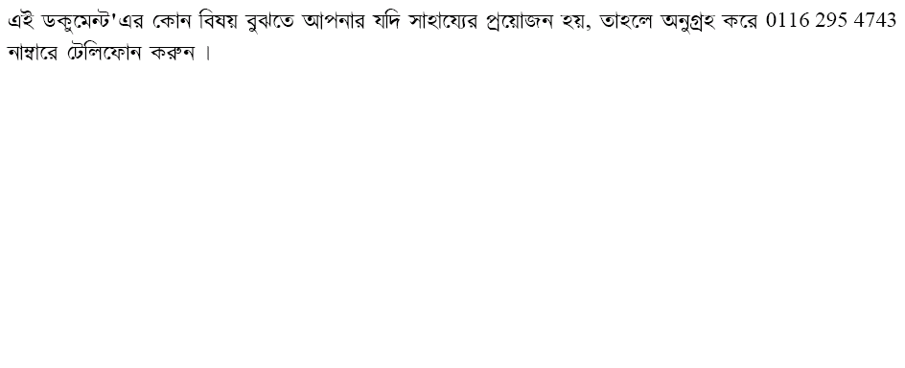







Caso pretenda ajuda para compreender o conteúdo deste documento, por favor ligue para o 0116 2954743.

如果您在理解本文档的内容时需要任何帮助，请致电 0116 2954743。

Jei norėtumėte, kad kas nors padėtų suprasti šį dokumentą, skambinkite tel. 0116 2954743.

Ja jums nepieciešama palīdzība, lai saprastu šī dokumenta saturu, lūdzam zvanīt uz 0116 2954743.