We hope you find the information in this leaflet useful, but if we can help in any way, please don’t hesitate to contact us
The Queens Road Medical Centre
220 Queens Road
Leicester
LE2 3FT

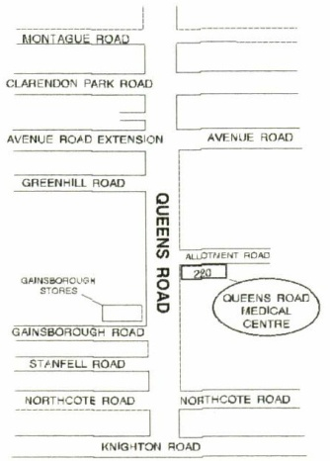

Dr. Jonathan Lenten (Male)
M.B.,Ch.B. (Leicester 1988) DFSRH
0116 2702233
fax 0116 2702232
www.tqrmc.yolasite.com

Practice Area
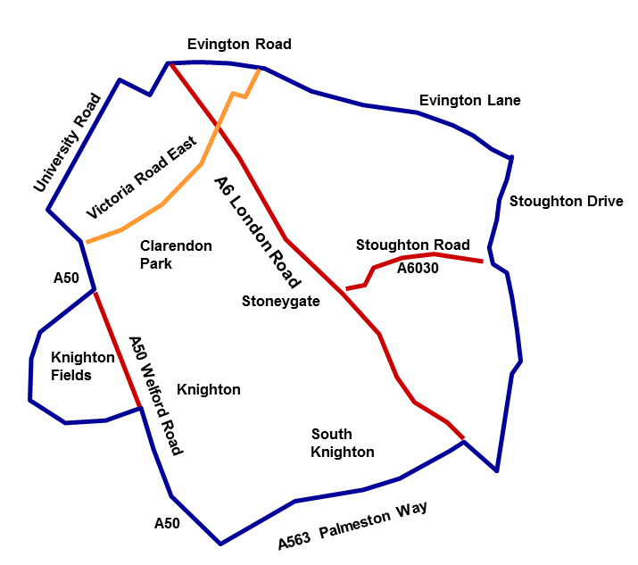
Most PHARMACIES can advise on minor illness. You can get advice from NHS 111 by ringing: 111. This is free from landlines and mobiles.
There is a 'walk-in centre' at 18 The Parade, Oadby. This is run by a private company
Details of medical services in the area can be obtained from the Area Team on 0113 8249588
6, Smith Way, Grove Park, Enderby LE191SX or from NHS Choices at www.nhs.uk/service-search

THE QUEENS ROAD MEDICAL CENTRE

SURGERY TIMES

We run a modified advanced access appointment system
This is a GMS Practice

Our Reception Is Open:
Monday - Wednesday & Friday |  | 3.30 - 6.30 pm
The surgery is closed on Thursdays from 12 noon
Monday
Doctor | 9.00 - 11.00 | 4.30 - 6.30
Practice Nurse | 8.30 -12.00 | 3.30 - 6.00
HCA | 8.30 - 11.00
Therapist | 9.30 -12.30
Tuesday  Doctor | 9.00 - 11.00 | 4.30 - 6.30
HCA | 8.30 - 10.30 | 3.30 -6.00
Wednesday
Doctor | 9.00 - 11.00 | 4.30 - 6.30
Practice Nurse | 8.30 - 12.00 | -
Midwife | 9.00 - 11.30 | (alternate weeks)
HCA | 8.30-11.00
Thursday |  | -
Doctor | 9.00 - 11.00 | -
Practice Nurse | 8.30 - 12.00
HCA | 8.30-11.00
Friday
Doctor | 9.00 - 11.00 | 4.30 - 6.30
HCA | 8.30 - 11.00
Practice Nurse | 8.30 - 12.00
Weekends and Bank Holidays | closed

FOR URGENT MEDICAL ADVICE IF WE ARE CLOSED
if it is life-threatening call 999
8am - 6.30 pm Monday - Friday ring: 0845 6031761
6.30pm - 8.00am Monday - Friday, at weekends
and Bank Holidays ring: 111
when you ring NHS 111, a trained adviser will ask you
questions to find out what is wrong, give you medical
advice and direct you to an Out of Hours Doctor
if this is necessary.
YOU CAN ACCESS SOME APPOINTMENTS, ORDER REPEAT PRESCRIPTIONS AND VIEW YOUR SUMMARY RECORD ON LINE. Ask the receptionist how to sign up
Practice Team Members

We employ the following staff:

Receptionists: Ian, Arvinder and Jane
Normally your first point of contact. Any information you give is treated in the strictest confidence. They may ask what you want to see the clinician about. This is done so that we give you the most appropriate appointment.

Complaints Manager: Ian

Practice Nurse: Helen Hampton, RN
Our nurse can be seen by appointment. She can perform asthma, diabetes, CHD and blood pressure checks. She also does blood tests, cervical smears, INR monitoring, holiday immunisations and other injections.

Health Care Assistant: Elaine Plumb, a level 3 HCA
Patients requiring blood tests will be requested to make an appointment with our Health Care Assistant. She also performs ECGs, INR monitoring, urine testing, health checks, and 24 hour Blood pressure monitoring.

Locum Doctors:
The surgery also employs additional, vetted, locum doctors. We try to use the same ones so that we can give as much continuity of care as we can.

Practice Manager: Sam Lenten
Deals with the administration, finance, staffing, PPG, etc.

Other allied staff not employed by us but part of the team providing your medical services:

Health Visitor:
Gives advice and monitors health and development in children and families. Tel: 0300 3000007
District Nurses:
Attached to our practice. Provide nursing care in the home when appropriate. Tel: 0116 2953366
Community Midwife:
Provide advice and care during pregnancy and after child birth. A clinic is held two weekly at the surgery.
Therapist/Counsellor:
We have a therapist /counsellor attached to our surgery.
Specialist palliative care nurse:
Employed by LOROS Hospice and specially trained to help patients and their families with end of life care.

Services We Offer

Child Immunisations
Full immunisation for all children is important. For advice on childhood immunisations contact the health visitor.

Antenatal Clinics
Antenatal care is provided in conjunction with the midwife. Postnatal checks are performed by the doctor at the 6 - 8 week baby check.

Family Planning
Family planning advice is given at the surgery.

Minor Operations
Various procedures can be carried out at the surgery. The doctor will inform you if this is possible for you. These include joint injections.

Blood Pressure Checks
Performed by the Practice Nurse/HCA.

Asthma / COPD Checks
Performed by the Practice Nurse.

Diabetic Checks
Performed by the Practice Nurse.

Coronary Heart Disease (CHD) checks
Performed by the Practice Nurse.

Blood / Urine Tests
Performed by our HCA. If your require a fasting test please request an early appointment.

ECG Test
Performed by the Practice Nurse or HCA. Please inform the receptionist that an ECG test is required so appropriate time can be given.

Wart Clinic
If you have a wart or verrucae, Dr. Lenten can freeze these off. Clinics are held every 3 months. Ask receptionists for details of the next clinic.

INR monitoring
Performed by the practice nurse or HCA. This is for certain patients who are taking Warfarin

Medicals
Dr. Lenten performs medicals for insurance, employment and other purposes. There are charges for these. Rates are available from reception.

Insurances Forms/ private letters
All are Non-NHS and there will be a charge for completion.

Holiday Immunisations
Make an appointment to see the practice nurse at least 8 weeks before you plan to travel. Some vaccinations are not available free of charge on the NHS, and the nurse will inform you if there is a charge.

Child Health Surveillance
Child development and health checks are performed by the Health Visitor and Dr. Lenten.

New Patient Registrations
If you are not registered with the practice and wish to join, please complete a registration form and health questionnaire. (from reception or the website) bring photo proof of your ID (eg passport/ new style driving licence) and of your address (eg a utility bill less than three months old – but not a mobile phone bill) and book in for a new patient health check.

Repeat Prescriptions
Repeat prescriptions should be requested in person, in writing, or online. Telephone requests will not be accepted for security and safety purposes. If a stamped addressed envelope is provided, repeat prescriptions will be posted to you. Please allow 48 hours for processing. In line with LeicesterCityCCG guidance we will only issue 1 month repeat prescriptions.

We use text messages to communicate with patients who have given us a mobile number. Please inform reception if you do not wish to receive text messages

Home Visits
If you believe you are too ill to come to the surgery, telephone the surgery before 10.00am giving full details and a contact number. A home visit will not be made without a contact telephone number. Please ensure someone is able to be contacted on the number you give.

Making appointments
This can be done in person, over the phone or on line. Please ensure that if you need to discuss more than one problem you inform the receptionist so that a longer appointment can be given. Please do not bring other patients with you to an appointment booked for yourself and expect the clinician to deal with them; they will need to make a separate appointment

Car Parking:
There is onsite parking at the rear of the surgery and on street parking on the Queens Road. The side road access must be kept clear at all times.

Facilities for the disabled:
Wheelchair access is via the main entrance. We have a toilet suitable for wheelchair users, and a dedicated disabled parking bay is in the car park. There is a hearing loop in reception. All our publications are available in large print on request.

Complaints:
We try to resolve these as quickly as possible in an informal way. However, if you wish to make a formal complaint, we will acknowledge it within 3 working days. Such complaints should be addressed to Dr Lenten. A copy of the complaints procedure is in the waiting room or you can talk to the Senior Receptionist who is our complaints manager. Someone will discuss the outcome of our investigation with you, or you will be sent a written response. We undertake to respond within 6 months though in the vast majority of cases it is much sooner.

Confidentiality and data protection
We recognise our obligations of confidentiality to all patients, including those under 16.
Information held may be used for management or audit purposes. Where possible this is made anonymous. The Care Quality Commission (CQC) has a legal right to access all our records, including those of patients as part of their inspection process.

Your medical notes may be shared with your consent to assist those involved in your care (eg allied staff such as District nurses). These staff will request your consent to access your records before doing so. These staff can record notes about their consultations with you (in the same way the GP does). This is called the ‘Enhanced Data Sharing Model’ (EDSM)

Different rules apply to your summary care record (SCR) which can be shared with other healthcare providers e.g. hospitals, or the OOH service to improve the care given to you across the NHS. You can refuse your consent to this information being shared.
See www.nhscarerecords.nhs.uk

Whilst the SCR mentioned above shares a limited amount of your medical access record to other healthcare providers, the Medical Interoperability Gateway (MIG) shares a much fuller view of your records but only with local NHS providers, and only when you give your express consent at the point of receiving that care (eg when you attend hospital). This is a view-only agreement and these NHS staff cannot add to your records.

Information such as your /gender/postcode/NHS no. (but not your name) may be shared with the Health and Social Care Information Centre, a Govt. body which plans healthcare. It may also access the information shared between healthcare providers, again for strategic planning. You can also refuse to give your consent for this.
See www.nhs.uk/caredata.

WE KNOW THIS IS A COMPLEX AREA. IF YOU CANNOT ACCESS THE INTERNET, OR NEED MORE INFORMATION ABOUT THIS, CONTACT THE SURGERY.

Apart from the situations described above where patients have to actively opt out of sharing their data, and except in specific circumstances, required by law, explicit Consent is needed from you before we divulge your information to anyone else.

Medicines
Please remember to store all medicines and tablets safely away from children. Take the full course of treatment as recommended by your doctor and do NOT give it to someone else. Do not use someone else's prescription medicines

Online prescription ordering/Appointment booking/viewing summary records
Please see a receptionist for a password to the secure link on our website, where you can find out more about accessing these on-line services.
Tests/reviews recommended by Clinicians
If the GP, Practice Nurse or HCA recommends a test or review at a later date IT IS YOUR RESPONSIBILITY TO ENSURE YOU BOOK AN APPOINTMENT AND ATTEND

Chaperones
If you would like a chaperone to be present during intimate or personal examinations, please inform the receptionist when booking. We will always try to accommodate requests for a chaperone.

Carers
If you are the carer for one of our patients, or you have a carer, or are a carer for someone else outside our practice, please tell Reception, and complete a carers form so that we can add you to the carers register. There is support and advice available for carers. You can contact Carers Direct on 0808 802 0202 or online at www.nhs.uk/carersdirect.

Interpreters
Please tell the receptionist at the time of booking if an interpreter will be required as these have to be arranged in advance. If you have requested an interpreter and need to cancel your appointment, please inform us as soon as possible so that we are not charged a cancellation fee.

Allocated GP for all patients
As we are single handed we would like to confirm that all patients registered with us are allocated to Dr Lenten.

Zero Tolerance
If a patient is threatening, violent or abusive we will take action to have them removed from our list of patients. If a staff member or other patient feels threatened, we will call the police.

Comments and Suggestions
Comments or suggestions regarding our services can be placed in our suggestions box by the front door/ given in at reception.

Patient Participation Group
This meets 2 times a year. (Minutes are on the website or from reception).If you would like to discuss an issue with one of the PPG members, you can do this by leaving a message with one of our receptionists. This can be put in a sealed envelope addressed to the PPG and handed in if you prefer.

Access to medical records
You have a legal right to see what is contained in your medical records. There may be some limitations. There is a maximum charge of £50 for this if you require copies. More information is available in the waiting room or by contacting staff. It is also on the website. Patients, or their nominated representatives, have the right to request access to their medical records within 21 days of receipt of a written request. You can also see them online in a summary form if you are registered to online services.

LAST BUT NOT LEAST ...

HOW CAN YOU HELP US PROVIDE A GOOD SERVICE?
~Only use one slot for one patient and one problem
~When seeing the GP, please mention your most important problem /symptoms first
~Let us know if you can't keep an appointment
~it is your responsibility to book in for any tests or reviews recommended by the GP, Nurse or HCA
~Inform us of a change of address/telephone number
~Be open and honest with the clinician seeing you about your medical history
~Do not use NHS services inappropriately e.g. A & E or the walk in centre
~Please do not get cross with our receptionists, they are only trying to help you

BEING WITH A SINGLE-HANDED PRACTICE

You have registered with a single handed GP. This means that you may have to be patient - Dr Lenten tries to give everyone the time they need, meaning sometimes others have to wait slightly longer than we would like. It also means that appointments to see him may be more limited. We try to offer as many appointments as we can, but please remember that Dr Lenten is only human and does need time off, so late evening and weekend appointments are not possible like they are in many larger multi partner practices. We are unable to offer appointments with a female GP.

PLEASE BEAR THIS IN MIND August 2015

